**Calorie Tracker App**

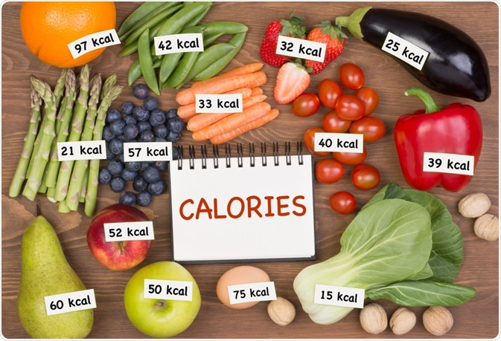

**PART 1: Problem-solving process to create a simple Python program via the shell.**

**I. Background**

Many people aim to maintain a healthy lifestyle by monitoring their calorie intake. This app assists individuals in maintaining a healthy lifestyle by facilitating the monitoring of their daily calorie intake. It features a basic calorie calculator designed to streamline the process of setting diet goals, whether it is weight maintenance, loss, or gain goals. Users can input their age, gender, weight, height, and desired diet goals. Utilizing the ‘Basal Metabolic Rate’ formula, the calculator estimates the total calorie intake required to meet the specified objectives, aiding users in tracking their progress towards their dietary targets.

**II. Business Rules**

1. **The Problem at Hand**

To address the challenge of maintaining a balanced diet and healthy lifestyle, there is a need to develop an app that offers users the ability to log their daily food intake to track their overall calorie consumption. It must be equipped with a calculator that provides users with estimates of their maintenance calorie intake, considering factors such as weight and dietary goals. By combining these elements into a single application, users can efficiently manage their dietary habits and progress towards their health goals, including weight loss and gain.

1. **Describing Inputs and Outputs**

To develop an effective solution, we require a comprehensive database encompassing a wide range of food items spanning various food categories. Each item in this database should be accompanied by its corresponding calories per gram. This database will serve as a crucial resource for the app's calorie calculator, enabling users to track their overall daily consumption of calories. Users interact with the app by setting their diet goals and providing inputs such as gender, age, weight, and height. With this information, the app estimates the number of calories users should consume to align with their specific dietary objectives.

**III. Develop a "Hand" Calculation**

The app features two calculators:

- The first calculator computes the daily overall calorie intake. It operates by recording each food item consumed along with the quantity in grams. Subsequently, it sums up the calorie intake from all items to determine the total calorie consumption.

- The second calculator gathers user information such as gender, weight, age, height, and diet goals. Utilizing the 'Basal Metabolic Rate' formula, this calculator provides an accurate estimate of the calorie intake required for users to meet their dietary goals.

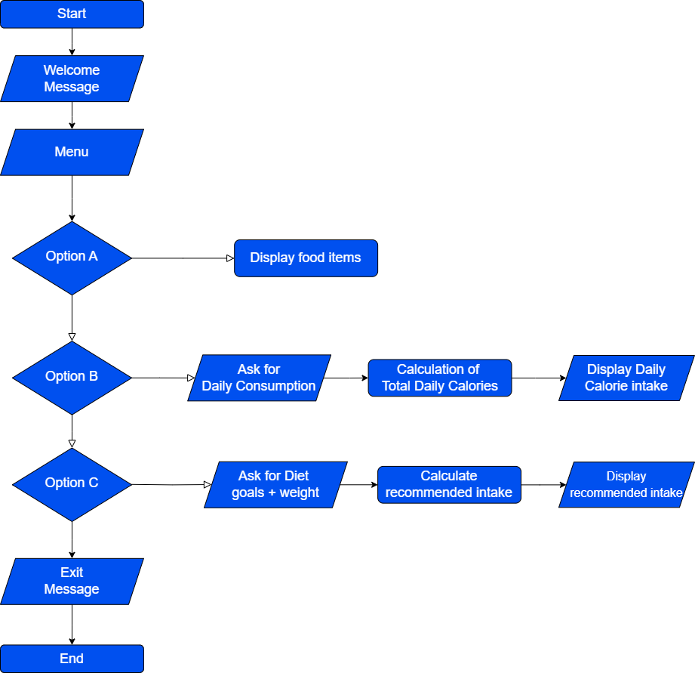

The above flowchart clearly shows the sequence of tasks that my program will be undertaking. I will now translate this flowchart into a pseudocode:

**Pseudocode:**  
  
**Program: Simple Calorie Tracker with Basic Calculator**

Start

Print "Welcome Message" on the screen.

Print "Menu" on the screen.

If [Option A] then

print food items on the screen.

Else if [Option B]

Input daily consumption of food items.

Calculate total daily calorie intake.

Summation formula [use the “displayCalculatedConsumption” function]

Print daily calorie intake on the screen.

Else If [Option C]

Input diet goals and weight.

Calculate recommended intake based on the goal.

Diet customization formula [based on user’s weight and goals]

Print recommended calorie intake on the screen.

Else If [Option D]

Print "Exit Message" on the screen.

End